

MUMS

Manufacturing Unit Monitoring System

Software requirement specification document

**Prepared by Team - 02**

Devi Dinesh (220340320036)

Manoj Deweda (220340320056)

Shubham Nandkumar Rane (220340320109)

Aniket Avinash Pattiwar (220340320021)

Akshay Balasaheb Jadhav (220340520016)

CDAC Kharghar & Juhu (March-2022)

9th August 2022

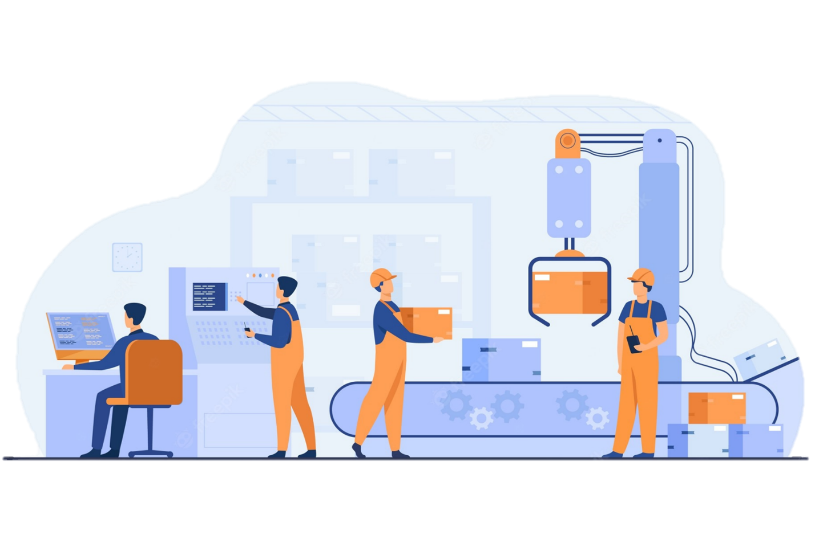

Index

|  |  |  |  |
| --- | --- | --- | --- |
| 1. |  | Abstract………………………………………………………………………………………………….. | 3 |
| 2. |  | Introduction…………………………………………………………………………………………… | 4 |
| 2. | A. | Product Purpose……………………………………………………………………………………... | 4 |
| 2. | B. | Product Scope…………………………………………………………………………………………. | 4 |
| 2. | C. | Product Audience……………………………………………………………………………………. | 4 |
| 2. | D. | Product Value…………….…………………………………………………………………………… | 4 |
| 3. |  | Purpose of the Document………………………………………………………………………… | 5 |
| 4. |  | General Description………………………………………………………………………………… | 5 |
| 4. | A. | Product Perspective……………..…………………………………………………………………. | 5 |
| 4. | B. | User Classes and Characteristics……………………………………………………………… | 5 |
| 5. |  | Users of the System and Features Included………………………………………………. | 6 |
| 5. | A. | Admin…………………………………………………………………………………………………….. | 6 |
| 5. | B. | Employee………………………………………………………………………………………………... | 6 |
| 5. | C. | Customer………………………………………………………………………………………………… | 7 |
| 5. | D. | Other Salient Features……………………………………………………………………………… | 7 |
| 6. |  | System Requirements……………………………………………………………………………… | 8 |
| 6. | A. | Software Requirements ………………………………………………………………………….. | 8 |
| 6. | B. | Hardware Requirements (Minimum) ……………………………………………………… | 8 |
| 7. |  | System Design………………………………………………………………………………………… | 9 |
| 7. | A. | ER Diagram (Table) ……………………………………………………………………………….. | 9 |
| 7. | B. | ER Diagram……………………………………………………………………………………………. | 10 |
| 8. |  | Use Case Diagrams…………………………………………………………………………………. | 11 |
| 8. | A. | Admin Use Case Diagrams………………………………………………………………………. | 11 |
| 8. | B. | Employee Use Case Diagrams…………………………………………………………………. | 12 |
| 8. | C. | Customer Use Case Diagrams………………………………………………………………….. | 12 |
| 9. |  | Sequence Diagrams………………………………………………………………………………… | 13 |
| 10. |  | Interface Requirements………………………………………………………………………….. | 14 |
| 10. | A. | User Interfaces………………………………………………………………………………………. | 14 |
| 10. | B. | Hardware Interfaces……………………………………………………………………………… | 14 |
| 11. |  | Other Non-Functional Attributes……………………………………………………………. | 14 |
| 12. |  | Future Scope…………………………………………………………………………………………. | 15 |
| 13. |  | Conclusion…………………………………………………………………………………………….. | 15 |

1. ABSTRACT

Small scale manufacturing industries comprise of small enterprises that manufacture goods with the help of smaller machines and a few workers and employees. These industries produce finished goods either for consumption or capital goods. These types of small-scale industries are generally individually owned. Examples of small-scale manufacturing industries are power looms, engineering industries, food processing, etc

Small scale industries in India are the lifeline of the Indian economy, and they offer several job opportunities for skilled labourers. After all, small scale industries are essential for the economy from a financial and social point of view. For a developing country like India, these industries bloom because of huge demand and opportunity. Some small-scale industries are also exporting goods, thereby bringing foreign currencies in India. In India, nearly half of the products (45-55%)** shipped are from small-scale and mid-scale industries.

The main objective of the project ‘MUMS – Manufacturing Unit Monitoring System’ is to provide one stop solution to the multitude of problems arising due to lack of resources and manpower in such small-scale industries. Keeping track of employees, the order details and other changes made becomes a huge hassle in such industries.

The idea of MUMS originated taking into account the constant struggle for maintaining records and tracking the activities in small scale manufacturing units. The project aims at providing a web service which can take care of employee and customer management, orders and production management while tracking the income and expenditure. MUMS also provides a solution for tracking the changes made through the activity log.

With the help of MUMS digitalization of data in such small organisation won't be difficult anymore. It also helps in maintaining transparency and reproducibility of data entered. With digitalised data these industries can keep themselves ready for surprise audits, quality control checks, financial audit, etc.

MUMS can set monthly target of employees (salesmen) based on their last three months of performance and can also do income prediction for the coming month based on the set targets. The graphical UI experience can help in analysing the performance and growth of the manufacturing unit easily.

MUMS will allow these manufacturing units to concentrate more on maintaining and improving their manufacturing process rather than wasting their valuable time on maintaining records, calculating salary, tracking orders, and other such everyday problems.

** https://www.lendingkart.com/blog/small-scale-industries-in-india/

2. Introduction

2. a. Product Purpose

To provide a system for data entry and retrieval. To provide a common and easy interface for the employees and customer for their different utilities and function. To reduce manual calculations and income prediction. For maintaining changes made to the data base, for future reference.

2. b. Product Scope

* Employee and customer login using username and password validation
* Segregation of employees as admin and regular employees
* Request for holidays for employees
* Placing of new orders using voice to text and viewing previous orders for customers
* Admin has access to multiple roles like
  + Adding new employee, checking, and modifying employee details, adding holidays and setting their monthly targets
  + Adding new customer, modifying the customer rating and other details, checking the order history of a particular customer
  + Checking all delivered and undelivered orders, changing the status of orders
  + Calculating monthly salary based on HRA, commission and holidays taken
  + Calculating monthly expense by adding various expense heads and checking for profit and loss
  + Prediction of the coming month income
  + Checking the audit logs as and when required
* Helper Bot (chat-box based on suggestion) for other small requirements

2. c. Product audience

Can be used by stand-alone small-scale and mid-scale manufacturing units with less than 100 employees. Specially designed for units with emphasis on single product production.

2. d. Product value

The value of the product lies in the fact that it helps in hassle free data maintenance, supervision-free production request, reproducible activity log for future reference. The time and manual effort saved in the above-mentioned activities helps in increasing the productivity of the manufacturing unit by helping it to concentrate more on manufacturing.

3. Purpose of the Document

This document aims at providing the adequate software requirements and specifications for using ‘MUMS’ efficiently. This document is intended for developers, users, testers and project managers for the purpose of understanding the system design of the web application in various perspectives. This document also specifies the functionalities that will be made available though MUMS for its different users. It also includes other information related to systems such as external interface requirements, features and other non-functional requirements.

4. general description

4. A. Product Perspective

MUMS is a replacement to the existing traditional method of book-keeping and paper-pen based method of data entry. These methods are unreliable due to possibility of human errors and difficulty in preserving and reproducing. The digitalisation provided by MUMS makes the industry future ready.

Target setting and income prediction is another important aspect which helps in setting a short-term goal at an individual and company level and helps in working sensibly towards achieving it. The easy-to-use user interface does not require a very tech-savvy person to handle it.

4. B. User Classes and Characteristics

The interaction between user and server can be classified into three namely ‘Admin’, ‘Employee’ and ‘Customer’. Admin plays an important role in maintaining, updating, and viewing database. Customer and Employee have access to few features through the system interface. The user need not have any prior knowledge of programming or problem solving to work with the system. A live demo of ‘how to use system’ is the only training required to use the system efficiently.

5. Users of the system and Features included

The User Interface of MUMS can communicate with 3 types of users through proper login

5. A. Admin

Post successful login the ‘Admin’ can access the following features

1. View all registered customers, view orders of a specific customer, modify details of a customer (name, rating, and status).
2. Add new customer, provide username and temporary password.
3. Assign Salesman to a new customer based on the city with just a button click.
4. View all registered employee, modify the details (basic salary, city, holiday, etc.).
5. Add a new employee, his/her details and provide username and temporary password.
6. Assign monthly targets for all the salesmen with just a button click.
7. View all orders, view all non-delivered orders, update order details (order status and batch number of the products delivered)
8. Calculate salary of all employees before the month end with just a button click.
   1. For regular employees: Total Salary = Basic + HRA $–$ Holidays.
   2. For salesmen: Total Salary = Basic + HRA + Commission $–$ Holidays.
9. Provide other expenses for a particular month like electricity bill, rent, and other miscellaneous expense to check the total income produced and profit/loss.
10. View the activity log, to check all the recent changes made to the database along with the information about who made the change
11. View income prediction and graphical representation of current income status
12. View salary details of past months
13. Change his/her own password and provide feedback

5. B. Employee

Post successful login the ‘Employee’ can access the following features

1. View his/her details.
2. Place request to change the details using the Helper-Bot
3. Place request for holidays
4. View salary summery and download salary slip
5. Change his/her own password and provide feedback

Salesmen (special case of Employee]

Other than the features accessible to regular employee, a Salesman can access the following

1. View customers and their order details (of last 3 months) assigned to him
2. View his/her assigned monthly target
3. View his/her performance graph

5. C. Customer

Post successful login the ‘Customer’ can access the following features

1. View his/her details.
2. Place request to change details using the Helper-Bot
3. Place new order using voice to text feature
4. View details of his/her previous orders
5. Change his/her own password and provide feedback

5. D. Other salient Features

1. Customer can place the order just by saying the number of units to be ordered
2. The order table is automatically updated, and production request is placed (in case of inadequate product availability) whenever a customer places the order
3. Graphical representation of data for better understanding of the trends
4. HRA is assigned to the employees based on the city of residence
5. Commission for salesmen is given based on his/her of experience in the company
6. Salesman is allocated to a customer based on his/her city.
7. Monthly target allocation to salesman is based on his/her last 3 months performance
8. Prediction of income is based on the monthly target set for salesmen
9. Floating feedback button on every login page
10. Helper-Bot for rare activity like request for changing details, sending suggestion to admin, raising complains, etc.

6. System Requirements

6. A. Software Requirements

|  |  |
| --- | --- |
| Technology | J2SE and J2EE, Hibernate, Spring Boot |
| Web-Technologies | React, CSS, JavaScript |
| Web Server | Tomcat 9.0 |
| Java Version | JAVA Version 11 |
| Backend Database | MySQL 8.0 |
| IDE | Eclipse |

6. B. Hardware Requirements (Minimum)

|  |  |
| --- | --- |
| Processor | Pentium IV |
| RAM Capacity | 1GB |
| Hard Disk | 160GB |

7. SYSTEM DESIGN

7. A. E-R DIAGRAM (Table)

7. B. E-R DIAGRAM (2)

8. USE CASE DIAGRAMS

This section presents a list of the fundamental sequence diagrams and use cases that satisfy the system’s requirements. The purpose is to provide an alternative, "structural" view of the requirements stated above and how they might be satisfied in the system.

8. A. Admin Use Case Diagram

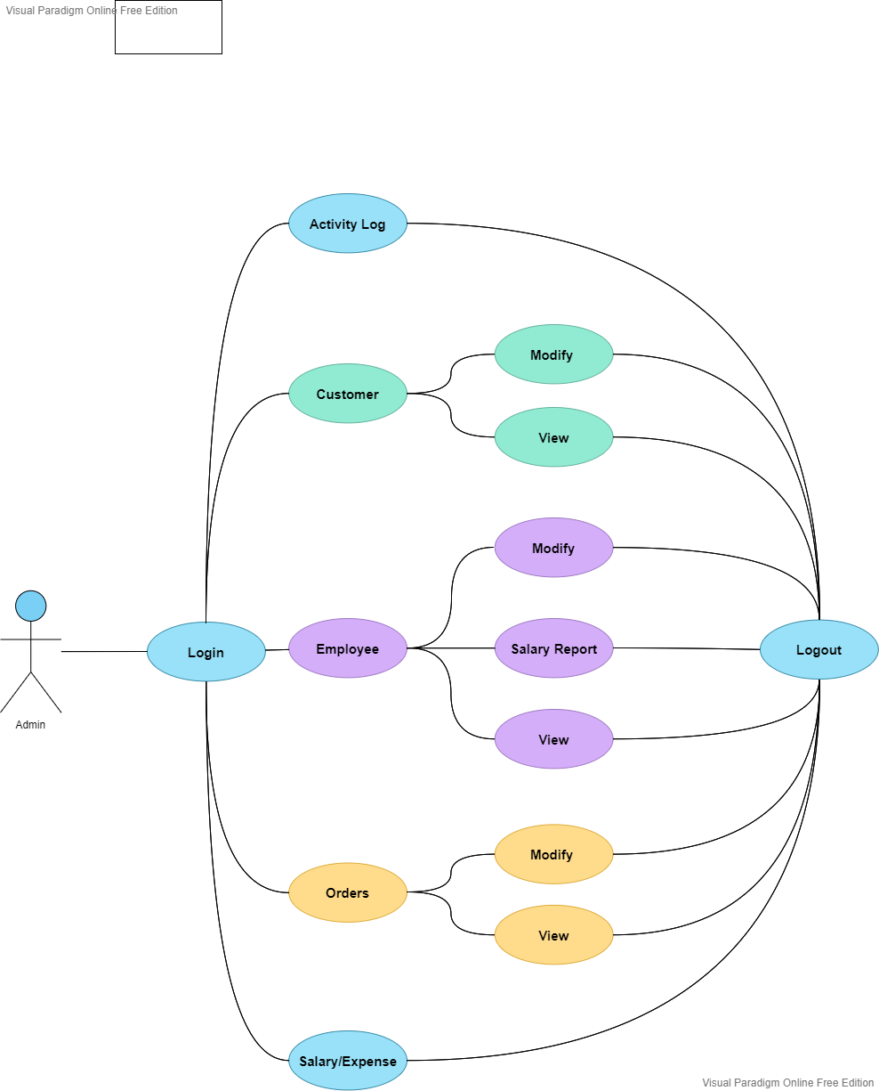

8. B. Employee Use Case Diagram

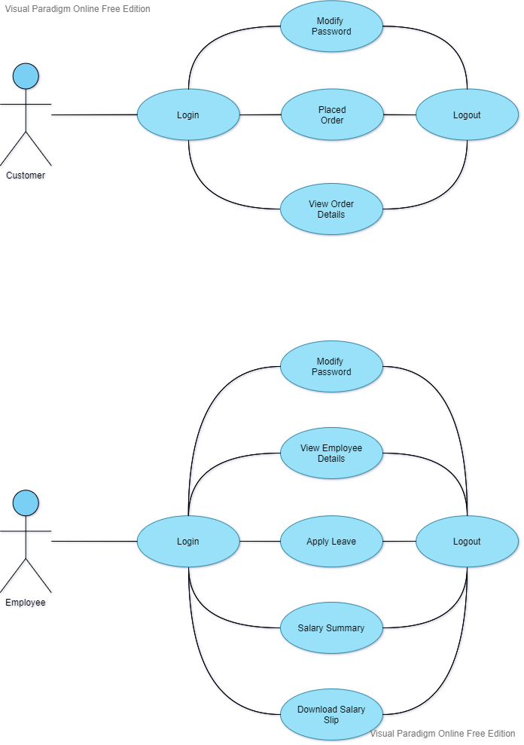

8. C. customer Use Case Diagram



9. SEQUENCE DIAGRAMS

10. Interface Requirements

10. A. User Interfaces

GUI (graphic user interface)

The user interface for this program is the interface provided by React using Chrome browser. It also uses the Google Forms service in the Helper-Bot.

CLI (command line interface)

There is no command line interface

10. B. Hardware Interfaces

The program uses the hard disk. Access to the hard drive and other hardware is managed by the operating system.

11. Other non-functional attributes

Security

The system shall be designed with a level of security appropriate for the sensitivity of information enclosed in the database. More interaction is needed with client about the volatility of the information. If required the database can be encrypted and/or the database can be password-protected, on user’s request.

Reliability

Reliability is one of the key attributes of the system. The system will be thoroughly tested by all team members to ensure reliability.

Portability

The system shall be designed in a way that shall allow it to be run on multiple computers with different types of browsers.

Extensibility

The system shall be designed and documented in such a way that anybody with an understanding of React, Spring Boot and MySQL shall be able to extend the system to fit their needs with the team’s basic instructions.

Serviceability

The maintenance of the system should be able to be sufficiently performed by any person with a basic understanding of React, Spring Boot and MySQL.

12. FUTURE SCOPE

The scope of expanding this project is infinite. Some of the features that can add more value to the project are

* IoT based Attendance Management System can be integrated into the project. It will help in keeping track of holidays taken by employees, rather than depending on admin to enter it manually.
* Automatic payment of salary to the employees on the specified date.
* As of now the service can handle only one product per company. It can be expanded to accommodate multiple products manufactured in same company.
* Distributed database will be more effective.
* Database can be encrypted and/or the database can be password-protected for additional security.

13. CONCLUSION

MUMS is a simple, but extensive web service, that is constructed to provide a one-stop-solution to all the data maintenance and analysis related problems that may originate in a small-scale manufacturing unit. It has a scalability of becoming an enterprise software. The user-friendly GUI and one-click solutions makes the project more usable. Using MUMS manufacturers can concentrate on the manufacturing process rather than the mundane work of book-keeping and calculation. And hence the tag line

*You Manufacture… We Monitor…*